**Investigating Graphs – Part A**

In previous work you learnt that the graph of $y=a{(x-b)}^{2}+c$ has the same shape as that of $y=ax^{2}$ but has been translated horizontally *b* units and translated vertically *c* units. The effect of the dilation factor, *a*,is to stretch or compress the curve depending on the value of *a.* Furthermore, if *a* was negative, the graph was inverted.

The aim of this investigation is to investigate translations and dilations in other functions.

### [2 marks]

On the axes below, accurately graph the following function: .

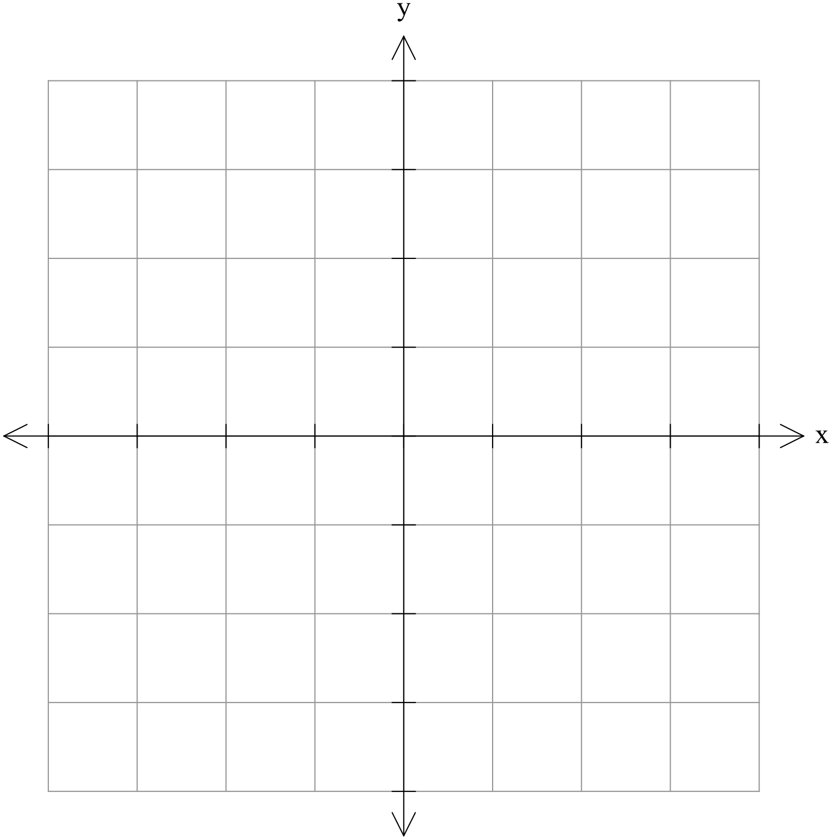

### [5 marks]

On the following axes, labelling everything clearly, graph the following functions:

and



### [4 marks]

On the following axes, labelling everything clearly, graph the following functions:

$y=\frac{-1}{x}$

and $y=\frac{-2}{x}$

### [3 marks]

Comment on the effects that changes in *a* have on the graphs of $y=\frac{a}{x}$ $(y=af\left(x\right))$.

### [5 marks]

On the following axes, labelling everything clearly, graph the following functions: 

$y=\frac{1}{x}$

$y=\frac{1}{x}+1$

and $y=\frac{1}{x}-2$



### [5 marks]

On the following axes, labelling everything clearly, graph the following functions:

$y=\frac{1}{x}$

$y=\frac{1}{x+1}$

and $y=\frac{1}{x-2}$

### [4 marks]

Comment on the effects that changes in *b* and *c* have on the graphs of $y=\frac{1}{x-b}+c$ $(y=f\left(x-b\right)+c)$.

### [3 marks]

On the following axes, labelling everything clearly, graph the following function:

$y=\frac{1}{x-1}+2$

### [4 marks]

(a) If the graph of $y=\frac{e}{x+1}+4$ has a *y-*intercept of 7, determine the value of *e*.

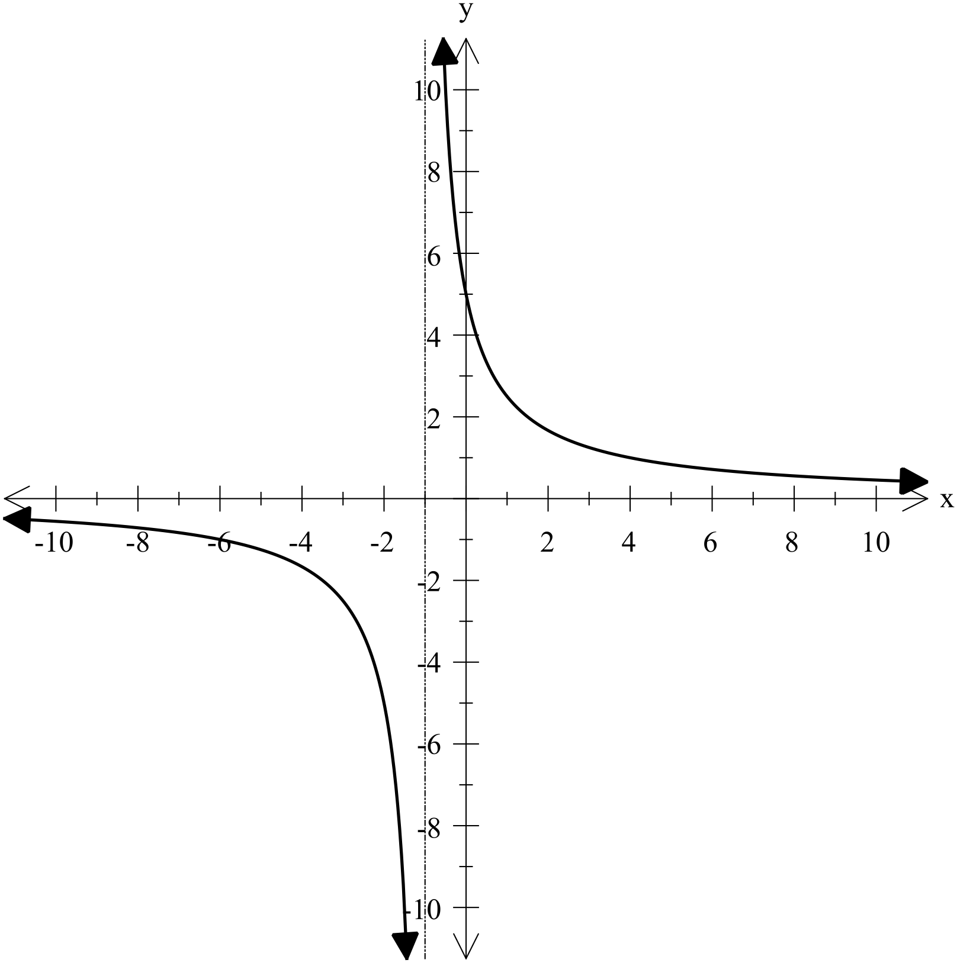

(b) The graph shown has an equation given as 

Determine the values of *r* and *s*.

**Investigating Graphs – Part A**

### [2 marks]

On the axes below, accurately graph the following function: $y=f\left(x\right)=\frac{1}{x}$.

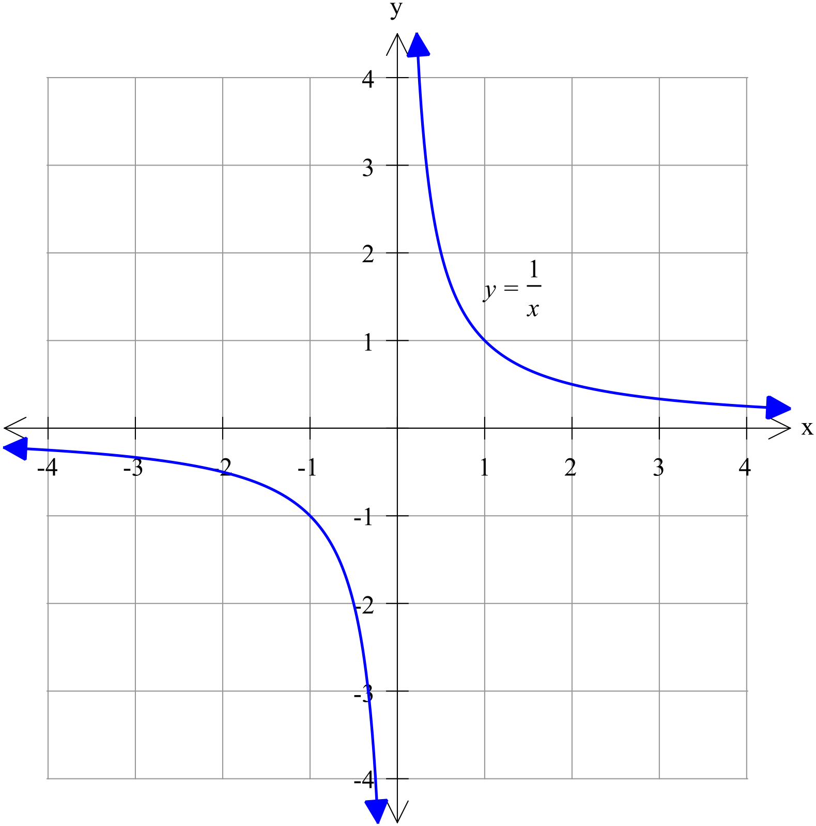

### [5 marks]

On the following axes, labelling everything clearly, graph the following functions:

and

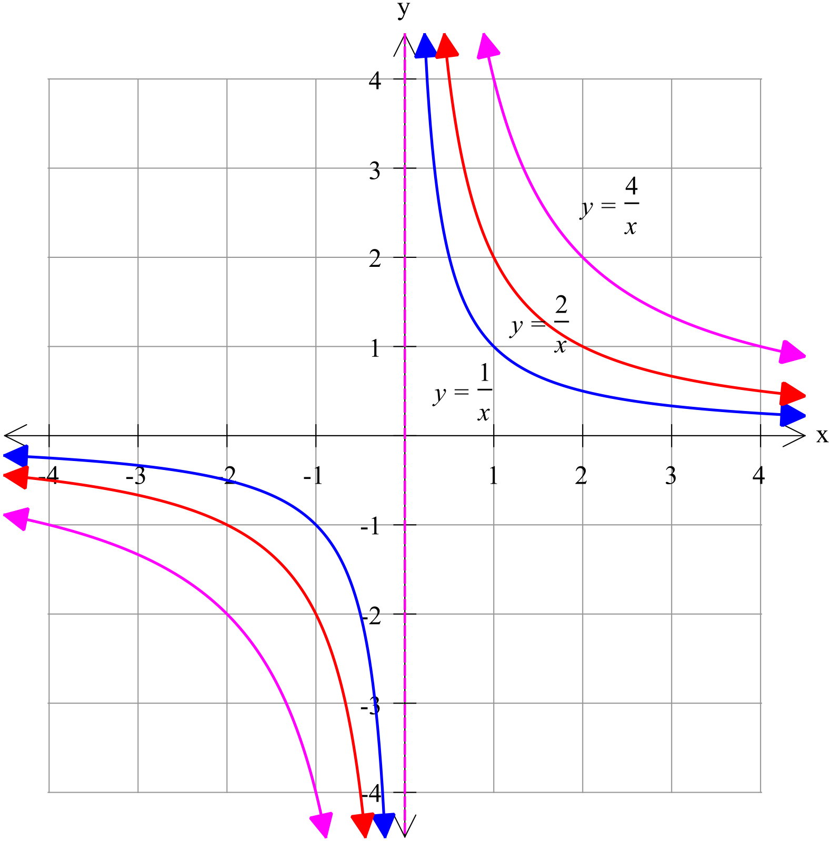

### [4 marks]

On the following axes, labelling everything clearly, graph the following functions:

$y=\frac{-1}{x}$

and $y=\frac{-2}{x}$

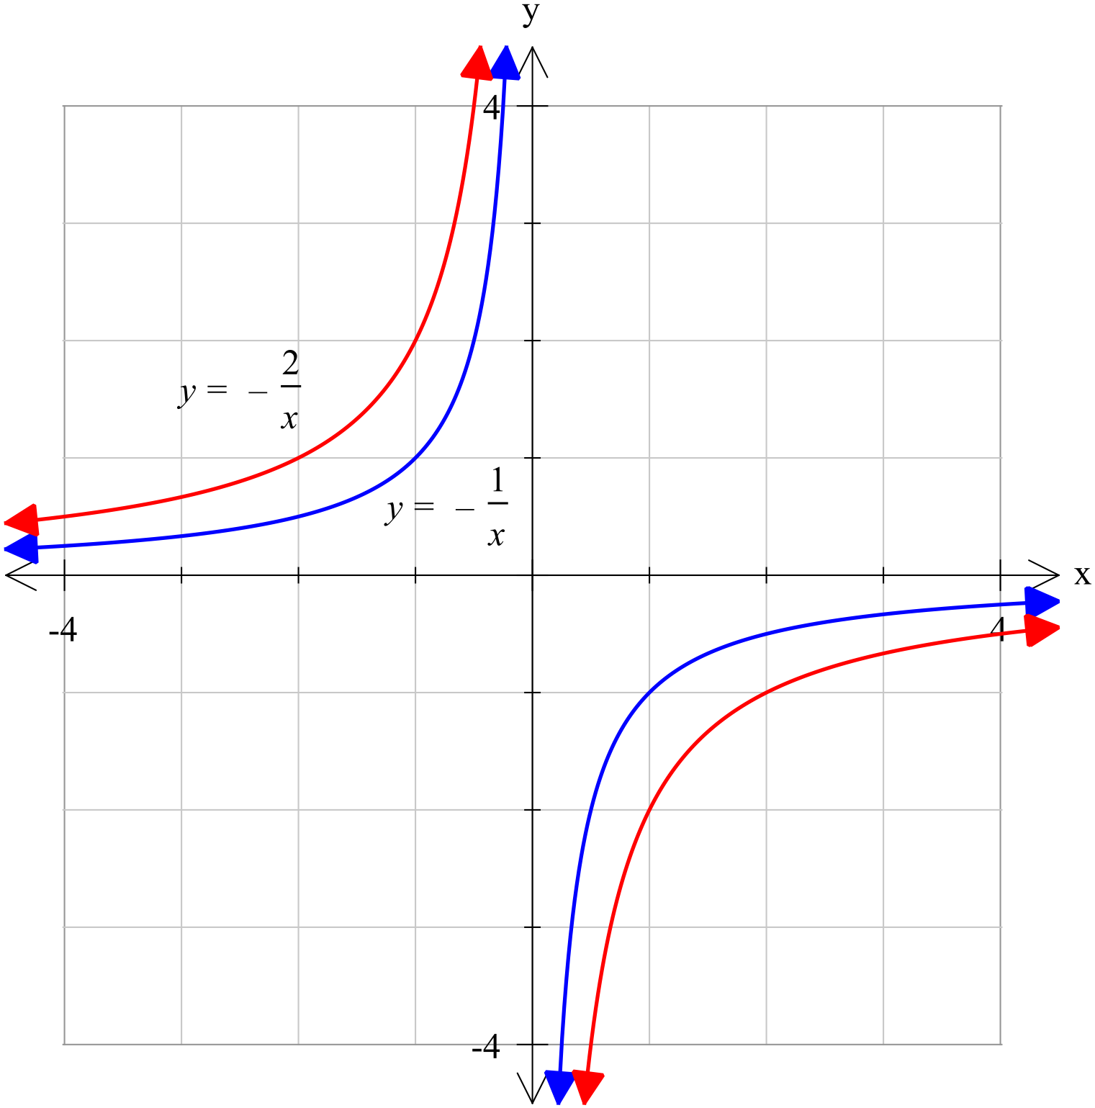

### [3 marks]

Comment on the effects that changes in *a* have on the graphs of $y=\frac{a}{x}$ $(y=af\left(x\right))$.

*a* is a dilation factor which stretches or compresses the graph of $y=\frac{1}{x}$ depending on the value of *a.* This affects the gradient of the curve and thus the distance the curve is from the axes. The larger the value of ⏐*a*⏐, the further it is from each axis.

Furthermore, if *a* is negative, the graph is inverted. That is the curves are in the second and fourth quadrants, rather than in the first and third.

### [5 marks]

On the following axes, labelling everything clearly, graph the following functions:

$y=\frac{1}{x}$

$y=\frac{1}{x}+1$

and $y=\frac{1}{x}-2$

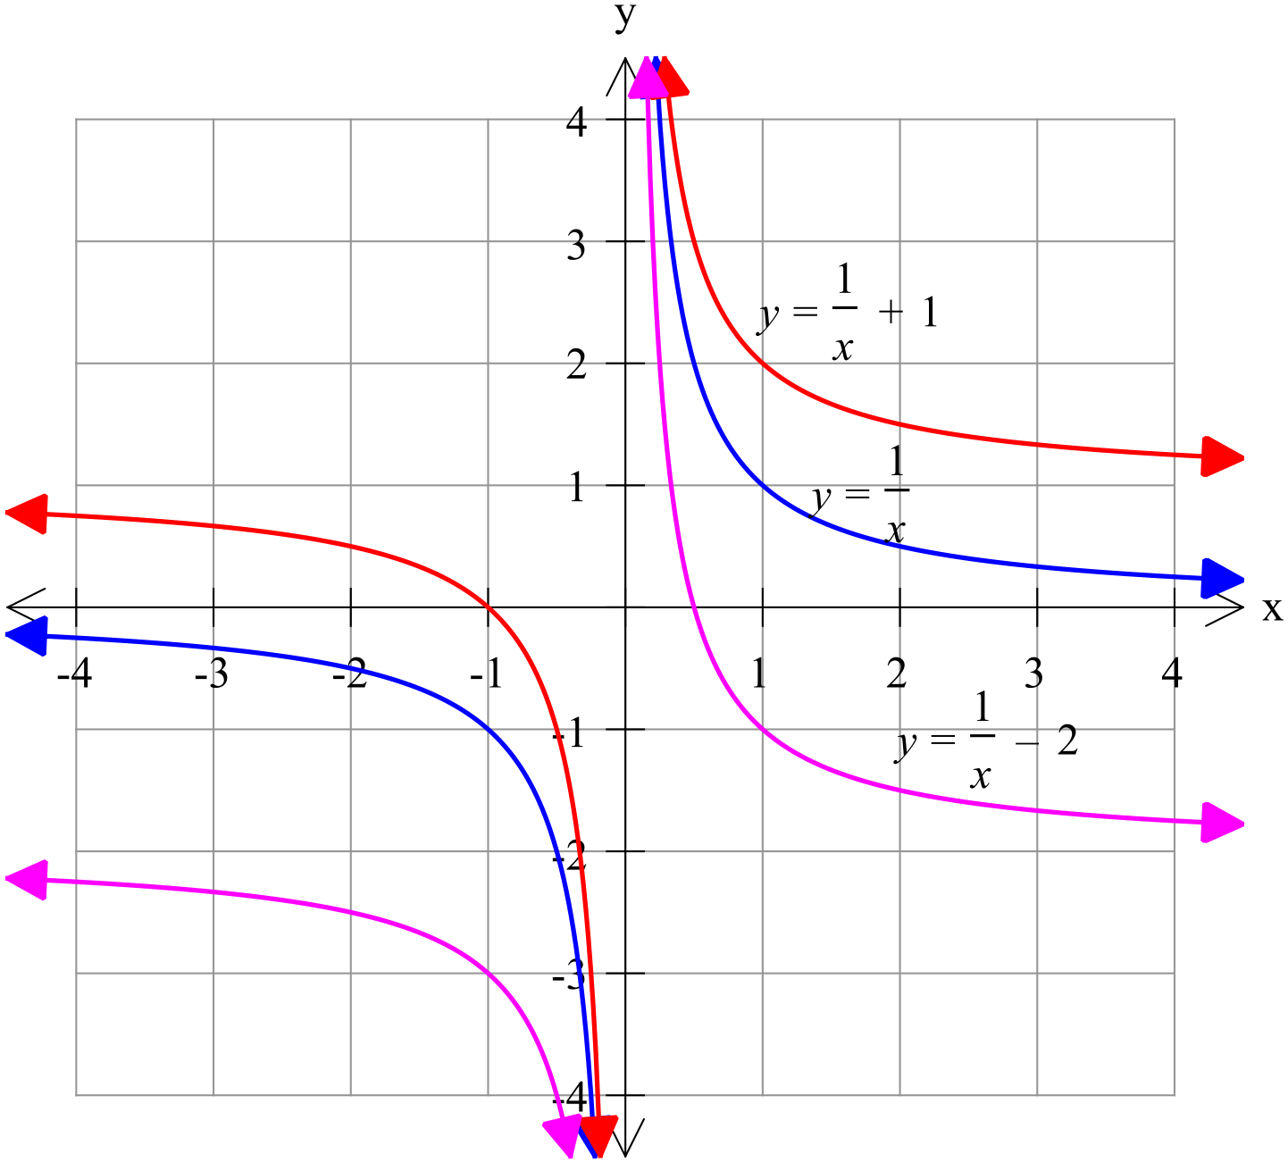

### [5 marks]

On the following axes, labelling everything clearly, graph the following functions:

$y=\frac{1}{x}$

$y=\frac{1}{x+1}$

and $y=\frac{1}{x-2}$

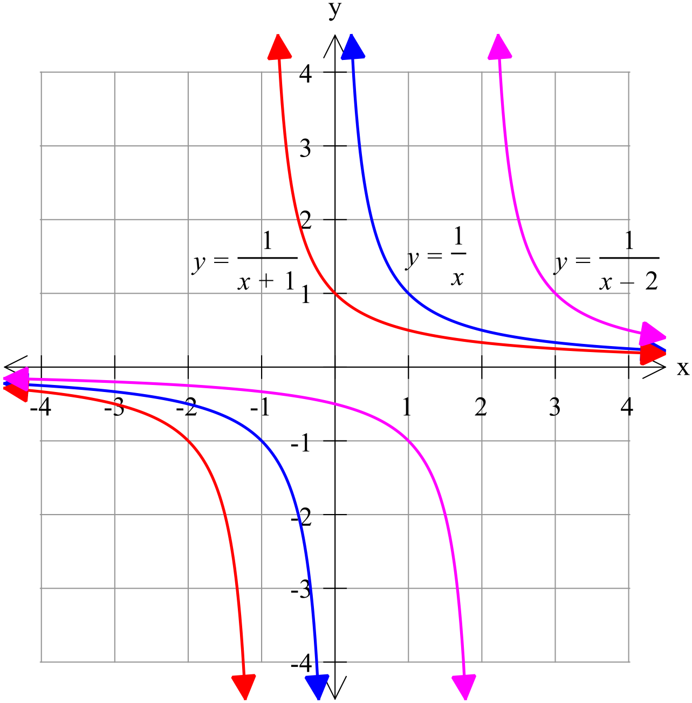

### [4 marks]

Comment on the effects that changes in *b* and *c* have on the graphs of $y=\frac{1}{x-b}+c$ $(y=f\left(x-b\right)+c)$.

$y=\frac{1}{x-b}+c$ is congruent to $y=\frac{1}{x}$ but has been moved *b* units right and *c* units up.

That is *b* is the distance of the horizontal translation and *c* the vertical translation.

### [3 marks]

On the following axes, labelling everything clearly, graph the following function:

$y=\frac{1}{x-1}+2$

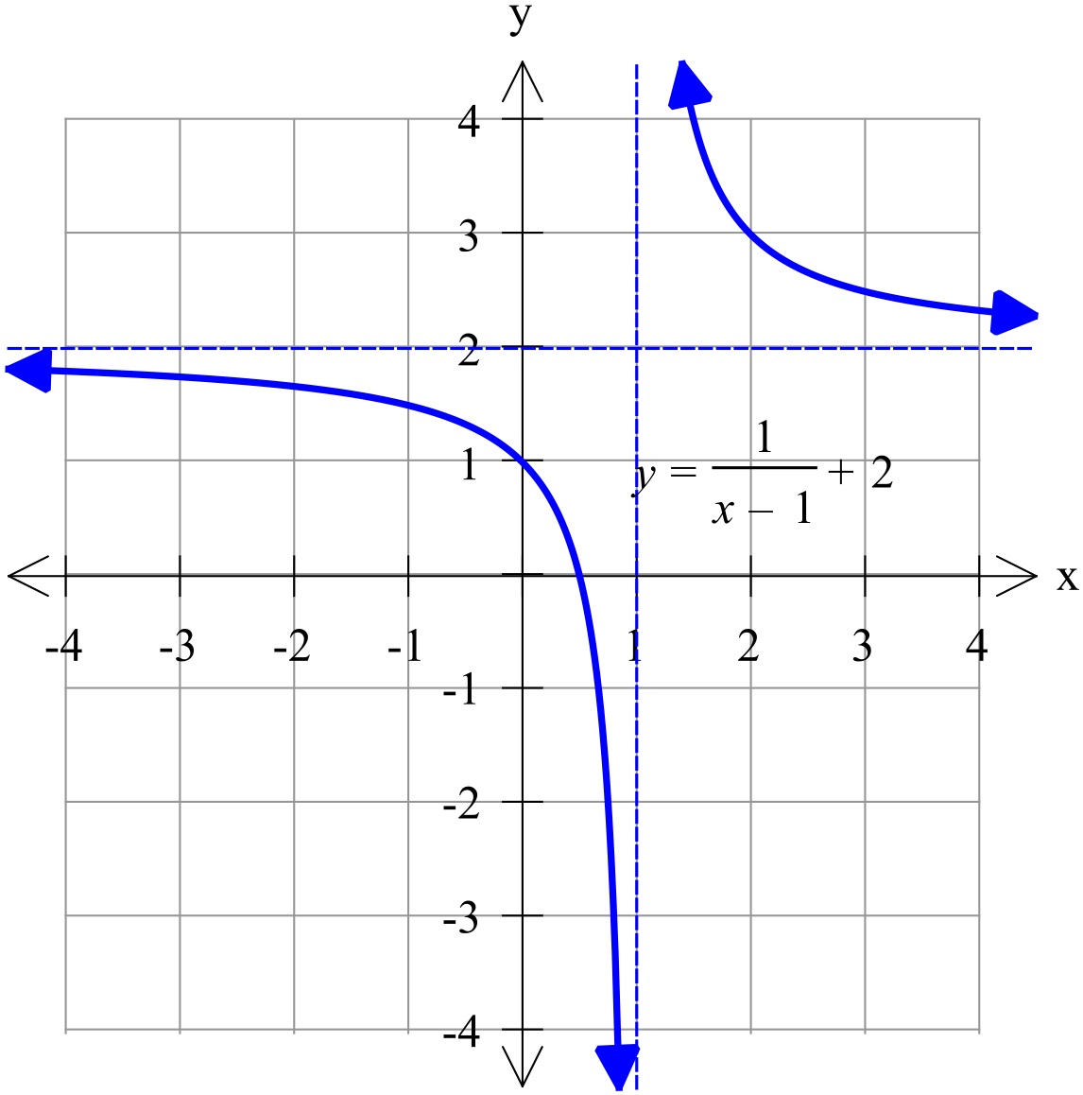

### [4 marks]

(a) If the graph of $y=\frac{e}{x+1}+4$ has a *y-*intercept of 7, determine the value of *e*.

(a)

$$y=\frac{e}{x+1}+4$$

$$7=\frac{e}{1}+4$$

$$e=3$$

(b) The graph shown has an equation given as 

Determine the values of *r* and *s*.

$$y=\frac{5}{x+1}$$

$r=5$ and $s=-1$

Total: 35 marks